**EVENTS PAGE - http://www.initc3.org/events**

The IC3 Blockchain Boot Camp – June 10-16, 2019

Cornell University

Ithaca, New York

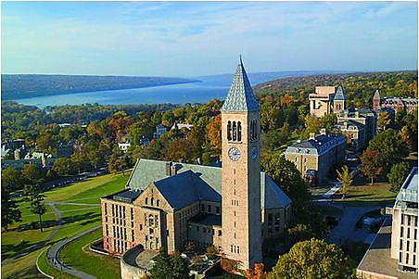

**This is an immersive weeklong coding and learning experience in Cryptocurrencies, Blockchains and Smart Contracts with world-leading professors, open source architects, scientists, engineers, developers and students.**

* Work on a dev team on a weeklong project, led by a blockchain expert.
* Attend daily presentations by smart contract and blockchain experts.

**Who should attend?** Experienced full-time blockchain architects, scientists, engineers, developers and students who want to learn, contribute and advance blockchain solutions.

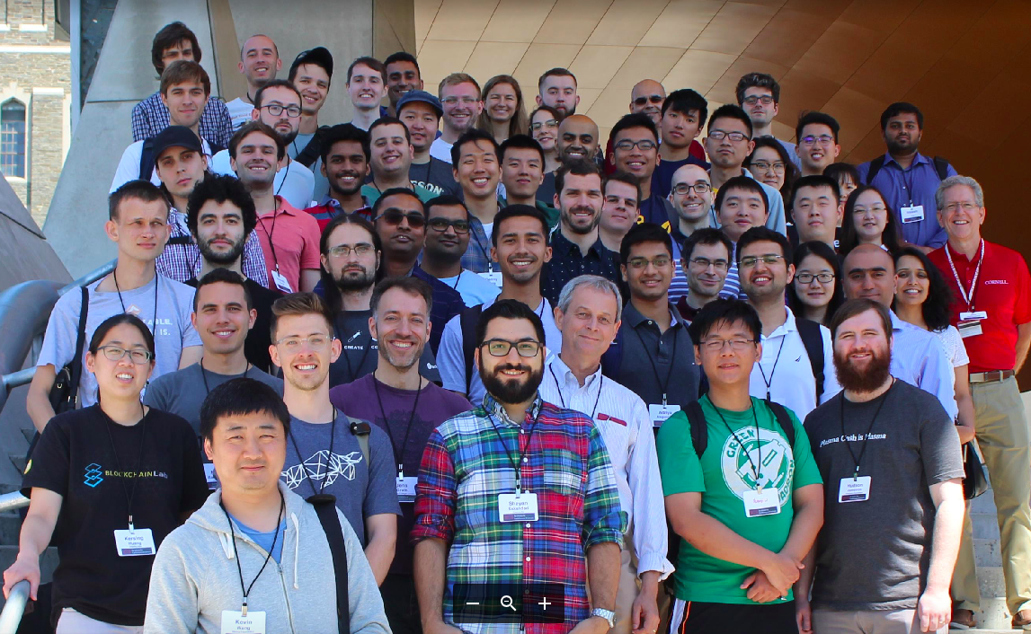**Many of the participants at the 2018 Boot Camp gathered for a Group Photo prior to lunch on Day 1, on the steps of Gates Hall.** [See a summary of the 2018 Boot Camp here.](http://www.initc3.org/events/2018-07-12-IC3-Ethereum-Crypto-Boot-Camp.html)

**NOTABLE ATTENDEES**

Join confirmed attendees this year including Vitalik Buterin, Hudson Jameson, Patrick McCorry, Andrew Miller, Emin Gün Sirer, Vlad Zamfir.

**FUN ACTIVITIES**

“Ithaca is Gorges”. To relax and clear our heads from time to time, we are planning periodic group excursions to local gorges, parks, lakes and points of interest.

**REGISTRATION and SPONSORSHIP**

**STUDENTS**: We are offering free access for a limited number of well-qualified full-time students enrolled at the IC3 campuses (Berkeley, Cornell, Cornell Tech, EPFL, ETH Zurich, UCL, UIUC, and the Technion); [please apply here.](https://docs.google.com/forms/d/e/1FAIpQLSfBq37rmPlBS0k8zuRwa8DltVYq7RcpkdOT15vPOd80HmR2aQ/viewform)

**INDUSTRY/PROFESSIONAL PARTICIPANTS:** All must be affiliated with an IC3 Member or a Boot Camp Donor (see details below).

**BOOT CAMP DONOR – $12.5k US**

* Donations support the Boot Camp, including scholarships for students attending for free, and on-going IC3 research.
* Includes Donor Brand logo on the IC3 website, and social media outreach.
* Includes Participation for one person for the full week of Hacking and Learning, plus participation in the Celebration Dinner on June 16.
* Includes Periodic Fun Activities.

**IC3 MEMBERS**

* Up to two employees of IC3 Members (see current list of members [here](http://www.initc3.org/partners.html)) may participate free of charge.

All Industry/Professional participants, [please apply here.](https://docs.google.com/forms/d/e/1FAIpQLSfBq37rmPlBS0k8zuRwa8DltVYq7RcpkdOT15vPOd80HmR2aQ/viewform)